Spring Thunder Roars at Mason Dixon Dragway

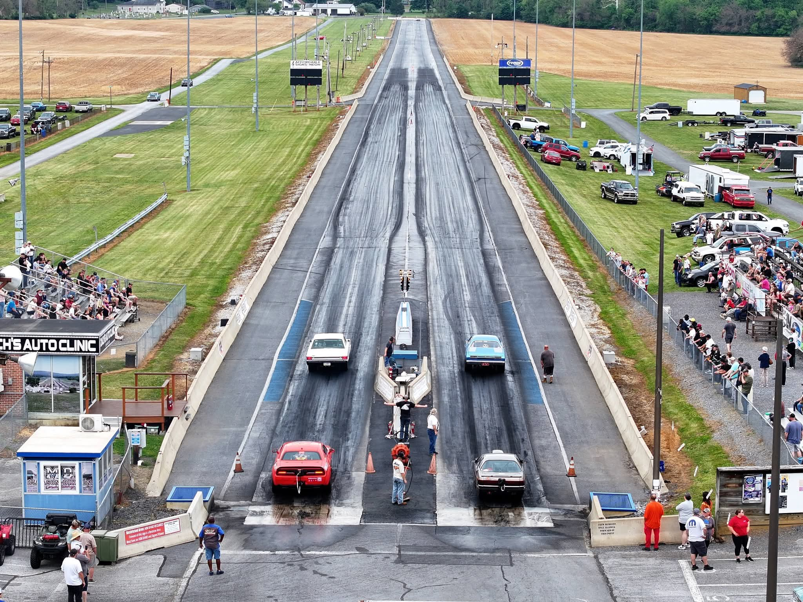

SBRA Competition, Mopar Power, and Perfect Late-May Conditions Highlight an Exciting Month

As spring temperatures finally settled into the Mid-Atlantic region, racers and fans packed the grounds at Mason Dixon Dragway for an action-filled month of competition featuring bracket racing, specialty events, gamblers races, and the ever-popular Mid Atlantic Mopar Meet.

From razor-thin reaction times to beautiful weather and packed pit areas, May delivered everything grassroots drag racing fans could ask for.

The month opened with the Southern Bracket Racing Association Series on May 2, bringing racers from Pennsylvania, Maryland, Virginia, and beyond to battle for early-season momentum. Tight competition across every class kept fans glued to the fence throughout the day as drivers chased consistency and reaction-time perfection.

In Jr. Dragster competition, Mallory Dietz of Hanover, Pennsylvania captured the victory over Braelin Bowie of Waynesboro, Pennsylvania. The motorcycle category saw Kevin Hamilton of Middletown, Maryland ride to victory against Boyd Mathias of Strasburg, Virginia.

The Mod Pro division featured strong side-by-side racing all afternoon, with Frederick, Maryland’s Dicky Bodmer taking the win over William Stotler of Winchester, Virginia. In Super Pro, Lin Bowie of Waynesboro earned the victory over Alex Maglaris of Amissville, Virginia after a highly competitive day in one of the track’s toughest categories.

Trophy class honors went to Mason Blumenaurer, while Cameron Bauman finished runner-up.

Throughout the event, racers delivered stellar reaction times and highly competitive elapsed times, showcasing the strength of the SBRA program and the deep level of talent regularly competing at Mason Dixon Dragway.

Two weeks later, May 16 delivered nearly ideal racing conditions as sunshine and warm temperatures welcomed racers preparing for the 42nd Annual Mid Atlantic Mopar Meet weekend. The pits filled quickly for Saturday’s Gamblers Race and East Coast Impala Racing Series action.

Brian Lind dominated the Gamblers Race in his A115 machine, earning the event victory along with Low ET honors at 5.791 seconds and Top MPH at 116.55 mph. Lind also posted the event’s best reaction time with a stellar .0119 light. Rick Wenger finished runner-up after a strong performance throughout eliminations.

The East Coast Impala Racing Series brought another competitive field to the property, with Glen Koenig defeating Karl Elmein in the final round. Koenig posted an impressive 11.963-second pass at 111.44 mph while also collecting Low ET and Top MPH honors for the category.

The momentum carried directly into Sunday’s 42nd Annual Mid Atlantic Mopar Meet, one of the region’s premier all-Mopar events and a long-standing tradition at Mason Dixon Dragway.

Fans were treated to a full day of Mopar-powered action under sunny skies and above-normal May temperatures. The event once again showcased everything from street-driven classics to dedicated bracket machines and high-horsepower race cars.

In Trophy Mopars, Poe Custer claimed victory over Lisa Meleo with a consistent performance throughout eliminations. Mike Daymude captured the Super Mopars victory after laying down impressive numbers including a 5.2480 Low ET and a blistering 132.98 mph top speed. Colby Imes finished runner-up in the category.

Street Mopars featured one of the strongest final-round matchups of the day, with Jeff Meleo taking the win after a 12.7275-second pass at 106.18 mph over runner-up Kevin Grasson. In Pro Mopar competition, Dylan Moyer earned the victory over Jeff Doster while posting a 6.6603-second Low ET.

Track staff kept the large event moving efficiently throughout the afternoon, helping make the 42nd annual edition another successful chapter in the event’s long history.

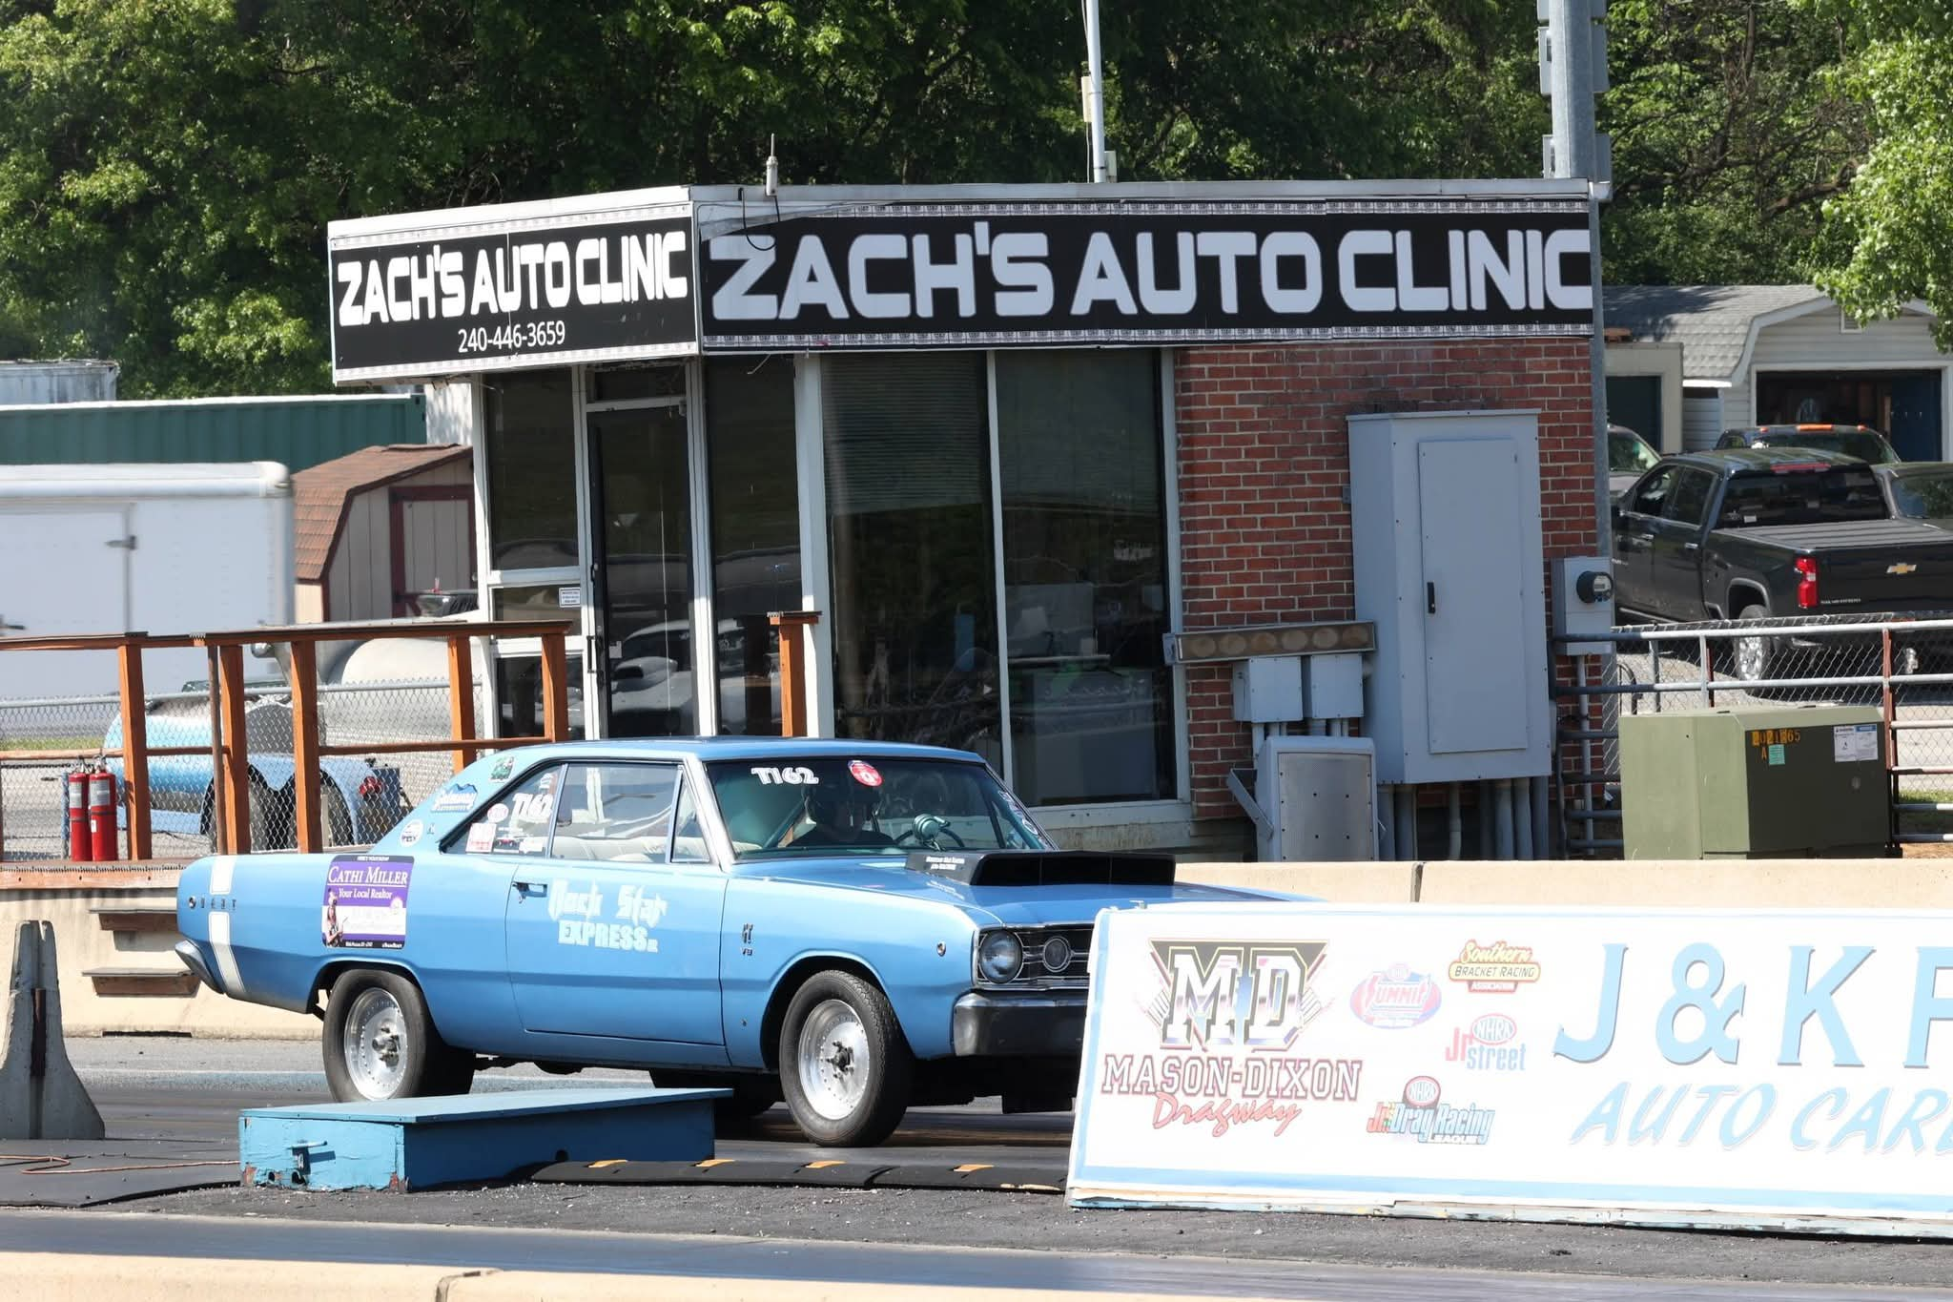

Unfortunately, Mother Nature interrupted the month’s momentum during Memorial Day weekend. A stalled cold front parked over the region and produced several inches of rain between May 22-25, saturating the facility grounds and forcing the cancellation of the entire four-day Memorial Day Classic weekend. Despite the disappointment, racers and fans quickly turned their attention to the final weekend of May.

The weather responded in spectacular fashion.

Perfect late-spring conditions greeted racers for May 29-31 as Mason Dixon Dragway hosted three full days of racing activity. Friday night featured the facility’s first nighttime Test and Tune session of the 2026 season, held beneath gorgeous skies and an almost full moon. Cooler evening air and packed staging lanes created a memorable atmosphere as racers fine-tuned combinations for the weekend ahead.

Saturday’s Street Race Series brought another packed house and nonstop action across multiple classes, giving racers and fans a full day of heads-up and bracket-style competition. Sunday wrapped up the month with another busy Test and Tune session as competitors prepared for upcoming Southern Bracket Racing Association rounds in early June.

Here's the results for May 29-31:

May 29 - Friday Night Test & Tune Gamblers Race

Winner: Ron Vito (41)
Runner-Up: Lucien Payne (267L)

May 30 - Street Race Series

Drive-In Street

Winner: Greg Orris (G185)
Runner-Up: Greg Garland (512)

Pro Street

Winner: Bob Reeder (601R)
Runner-Up: Gary Kelican (2891)

6.50 Index

Winner: Ron Gusack (157)
Runner-Up: Dave Slusher (138)

Quick 16

Winner: Mitch Willingham (1578)
Runner-Up: Tracy Stroop (396)

5.90 Index

Winner: Joey Harrison (542)
Runner-Up: Dan Slusher (1579)

7.10 Index

Winner: Ron Vito (41)
Runner-Up: Lance Kreiger (110K)

Nasty 9's

Winner: Dan Ryntz (3001)
Runner-Up: Charlie Booze Jr. (3398)

Modern Muscle

Winner: Sean Herrick (25X)
Runner-Up: Greg Orris (G185)

MD275

Winner: Bobby Demitt (13)
Runner-Up: Cole Luttrell (11X)

Sportsman

Winner: Wesley Fournier (304)
Runner-Up: Nathaniel Huffman (281)

Street X

Winner: Richie Stine (90X)
Runner-Up: Bryon Wright (14W)

May 31 - Test & Tune Gamblers Race

Winner: Cole Francis (N195)
Runner-Up: Steve Gasnell (1720)

With strong racer support, packed pit areas, and an exciting schedule still ahead, Mason Dixon Dragway continues to prove why it remains one of the Mid-Atlantic region’s premier destinations for grassroots drag racing.

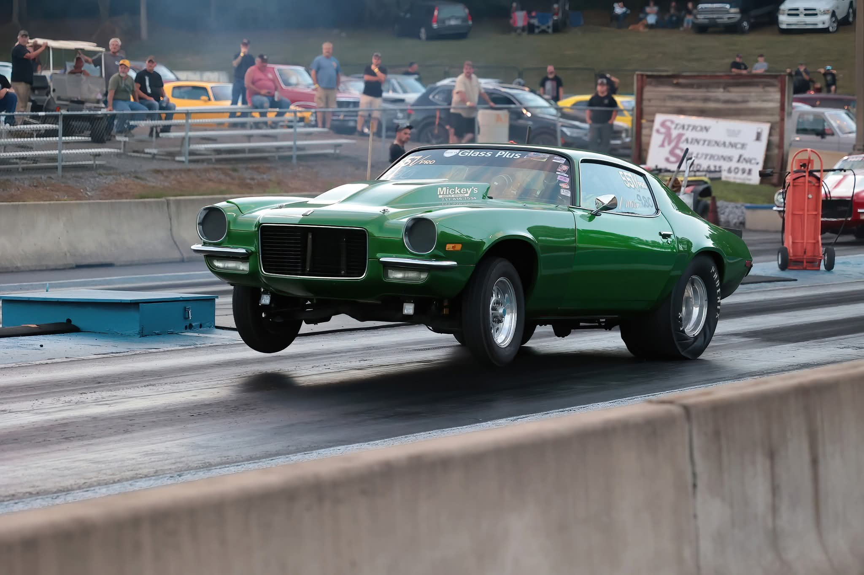

For upcoming events, race schedules, and track information, visit masondixondragway.com

Author - Russ Toms
Photos - Mike Parker

