21344 National Pike, Boonsboro, MD 21713  Phone (301) 791-5193  GM- Jake Landes (301) 991-8762 Tkdgold2000@gmail.com  Owner – Elmer Wachter dragway1@aol.com | 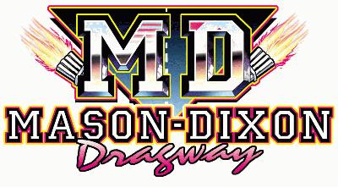

Sponsorship | 2025 season
sponsors NAME: |  | ORGANIZATION:
sopnsorship type |  |  | price Per Year | X
Signs
4 X 8 Sign Winner circle |  | 1 Season Spectator Pass | $500
4 X 8 Bleachers |  | 1 Season Spectator Pass | $500
4 X 16 sign |  | 2 Season Spectator Passes | $1000
Tower |  | 4 Season Spectator Passes | $2000
Center Marker (Tree) |  | 2 Season Spectator Passes | $1500 | XX
Center V |  | 2 Season Spectator Passes | $1000 | XX
Starting Line Jersey Wall Both sides | 2 Season Spectator Passes |  | $1000
Scoreboards |  | 4 Season Spectator Passes -3 Year Contract | $2000 | XX
Class Sponsorship
Class |  | Duration of Contribution | Amount
 |  | Season/Race/Rounds
Description:

Total:
DUe BY: | SIGNATURE:
Thank you for your business!
Season Sponsors Organization Logo will be Applied to MasonDixonDragway.com Logo will have Clickable Links to Sponsors Organization Website.
For Sign $500 Minimum Deposit to Reserve Sign Location and Prepare the Sign
100% of the Sponsorship Money Must be Paid in Full to Install Sign
100% of the Sponsorship Money Must Be Paid in Full Before Race Dates
100% of Sponsorship Money Goes Back to The Racer/Class/Points/Trophies

